TASK 6
Objective
- To perform image classification using pretrained convolutional neural networks.
- To predict the top-5 labels for an input image.
- To compare the performance of different deep learning architectures.
Input Image
- A car image, and a complex image with multiple objects was used as input for the classification task and also to understand that which architecture among VGG16 and ResNet50 performs well .
- The image was preprocessed by resizing, center cropping, converting to tensor, and normalizing using ImageNet statistics.
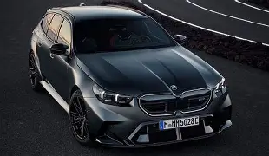
- The processed image was then fed into pretrained models for prediction.
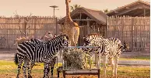
Models Used
- In the initial experiment, two pretrained convolutional neural network models, VGG16 and ResNet50, were used for image classification.
- Each model produced probabilities for all 1000 classes. The top 5 predictions with the highest probabilities were extracted to determine the most likely labels for the input image.
Results for image 1
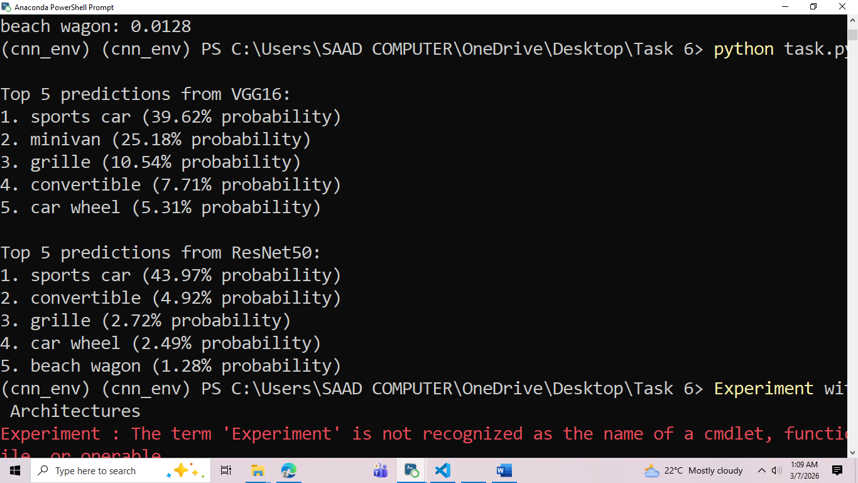

Results for image 2
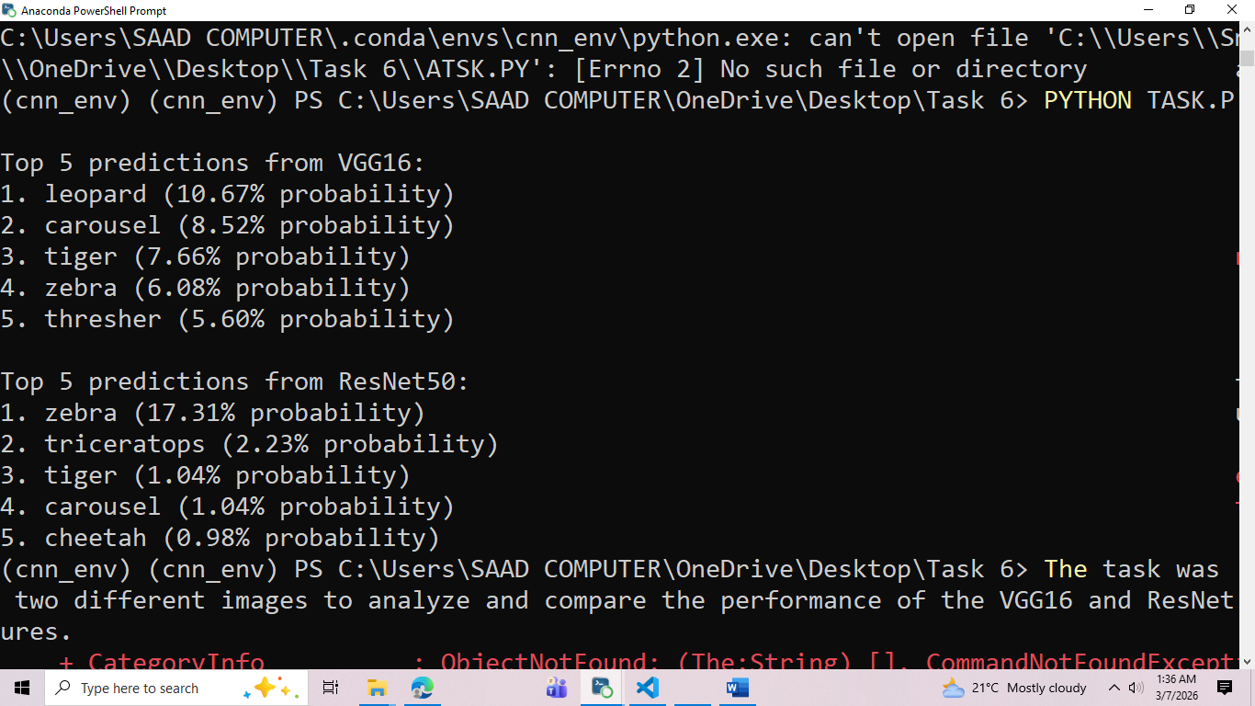

TASK 2
Experiment with Different Architectures
- Alex Net
- ResNet101
- Mobile Net
For image 1 For Image 2
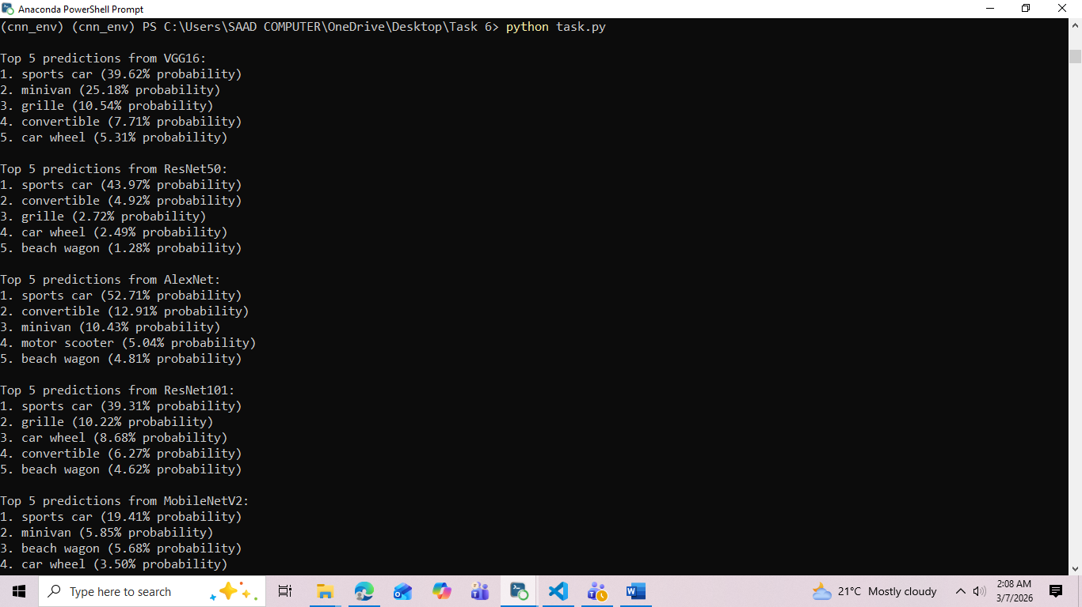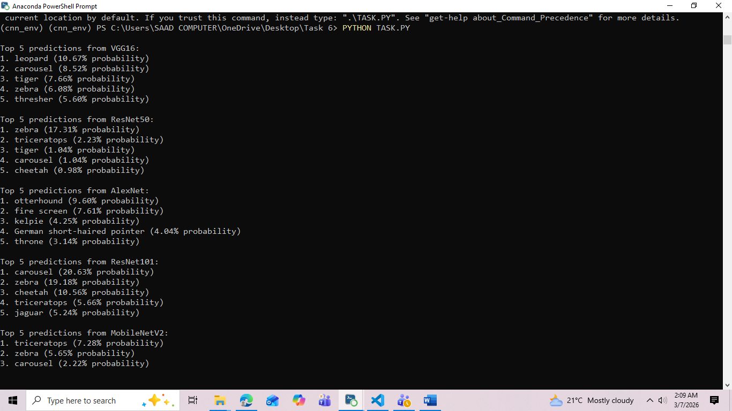

RESULTS AND ANALYSIS
- Car Image (Simple Single-Object Image)
- For the car image, AlexNet and ResNet50 showed higher confidence probabilities, with the car being correctly classified as sports car.
- VGG16 also correctly identified the car but distributed probabilities among related vehicle classes such as minivan and grille.
- MobileNetV2 produced lower confidence scores due to its lightweight architecture.
This shows that simple and clear images are better handled by texture- and structure-based CNN feature extraction.
- Multi-Animal Image (Complex Image)
- For the multi-animal image, predictions were more diverse due to the presence of multiple objects.
- ResNet101 and ResNet50 performed relatively better by identifying structural features such as zebra stripes.
- VGG16 spread probabilities across visually similar animal classes.
- AlexNet produced less semantically consistent predictions in this case.
This demonstrates that deeper architectures are more suitable for complex images with multiple visual patterns.
CONCLUSION
- AlexNet
  - Best suited for simple and clear single-object images where texture and edge features are dominant. It is computationally light but less effective for complex feature extraction.
- VGG16
  - Suitable for texture-based and moderately simple images. It works well when the object has clear local patterns such as vehicle body structure or animal fur texture.
- ResNet50
  - More suitable for complex images containing structural variations. It performs better when objects have shape variations, lighting differences, or partial background noise.
- ResNet101
  - Best for highly complex images and multi-object scenes because of deeper residual feature learning capability.
- MobileNetV2
  - Suitable for real-time and resource-constrained applications, but not ideal when high prediction confidence is required.

TASK 3
Use transfer learning for a data set if u have or download.
- Transfer learning is a deep learning technique where a pretrained model is reused for a new but related task.
- A pretrained ResNet-50 model was used for this task.
- The model was originally trained on the ImageNet dataset, which contains millions of labeled images.
- The pretrained layers of the model were frozen so their learned features were not changed during training.
- The final fully connected layer was replaced with a new layer to classify the dataset classes (cats and dogs).
- The model was then trained on the new dataset using the training images.
- During training, loss decreased and accuracy increased, showing that the model successfully learned the task.
- Transfer learning helped achieve high accuracy with fewer training epochs and less training time.

